Rachel Burke

Professor Linos

SE463

08 April 2018

Assignment 18

For this assignment, I selected the Strings Test Unit project from Assignment 16. First, I opened the entire solution and opened the SpecialValueTests.cs and strManipulator.cs files. To generate the code metrics, I clicked on Analyze > Calculate Code Metrics > For Solution in the Menu Bar at the top of the Visual Studio window. This calculated all code metrics and displayed them at the bottom of the Visual Studio window in a Code Metrics Results window. I selected the dropdowns on all items listed in the window to view all the results, which are displayed below in the screenshot.

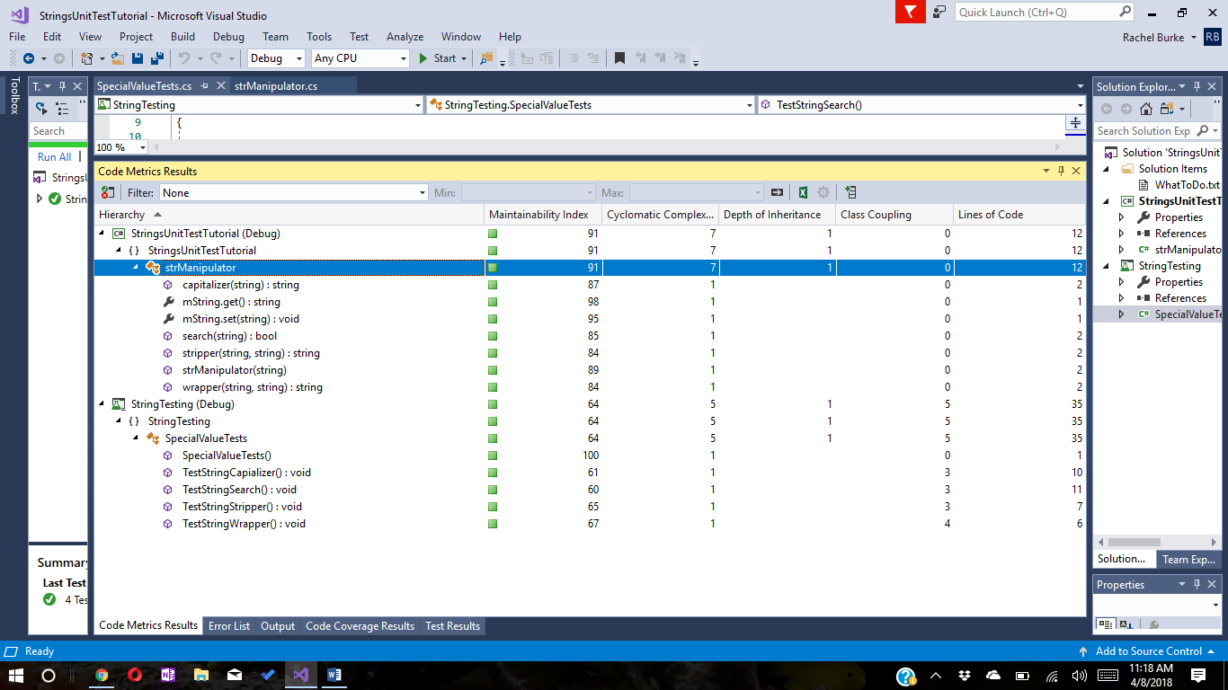

To accomplish the second task, I again went to the Menu Bar in Visual Studio. This time I clicked on Test > Analyze Code Coverage > All Tests. The Code Coverage Results window displayed in the bottom of the Visual Studio window. I selected the dropdown on all the items displayed in the window to view all the information. The screenshot below displays all of the results for the Code Coverage Results.

